Skeleton Crew
By Dominique Morisseau
A TDAPS Thesis Production for Prentiss Patrick-Carter and Amara Neal

Who?
Director: Prentiss Patrick-Carter
Executive Producers: Amara Neal & Prentiss Patrick-Carter
Producers: Nicolas Maynulet & Abigail Murphy
Stage Manager: Rena Kawasaki
Preferred Contact Email: skeletoncrewyale@gmail.com

What?
At the start of the Great Recession, one of the last auto stamping plants in Detroit is on shaky ground. Each of the workers have to make choices on how to move forward if their plant goes under. Shanita has to decide how she'll support herself and her unborn child, Faye has to decide how and where she'll live, and Dez has to figure out how to make his ambitious dreams a reality. Power dynamics shift as their manager Reggie is torn between doing right by his work family, and by the red tape in his office.

When?
Initial Auditions: August 30th - September 1st
Callbacks: September 4th
Casting Day: September 7th
Rehearsals begin: September 10th
Tech Week Dates: November 16th - December 3rd (minus November break)
Performance Dates: December 4th - 6th
Strike: December 6th and 7th
Overall Dates (First Rehearsal to Last Performance): September 10th - December 6th

Time Commitment
This show hinges on these 4 characters operating as a tight-knit almost familial unit. Since every character is vital to this show, all actors should expect to commit 8-10 hours per week and 4-6 hours per day during tech rehearsals.

We want this process to be a balance, one where actors feel comfortable with the workload of the show while simultaneously encouraged to challenge themselves and stray outside of their comfort zone. While the entire team is here to support you throughout this process, we expect all actors to be committed to the project.

Content Warnings
Moments of intimacy depicted onstage (see character list). There are no depictions of stage violence or high-risk movement. A firearm is presented multiple times and handled by Dez and Reggie as a prop, but never used for violence.

Audition Expectations
Prepare the audition sides for one (or more) characters.

Audition Dates/Location(s)
Auditions: August 30th - September 1st (tentatively in LC 317)
Callbacks: September 4th (tentatively in LC 317)

Table of Contents
Meet the Team
The Cast
Audition Details
Accessibility
Contact Us

Meet the Team
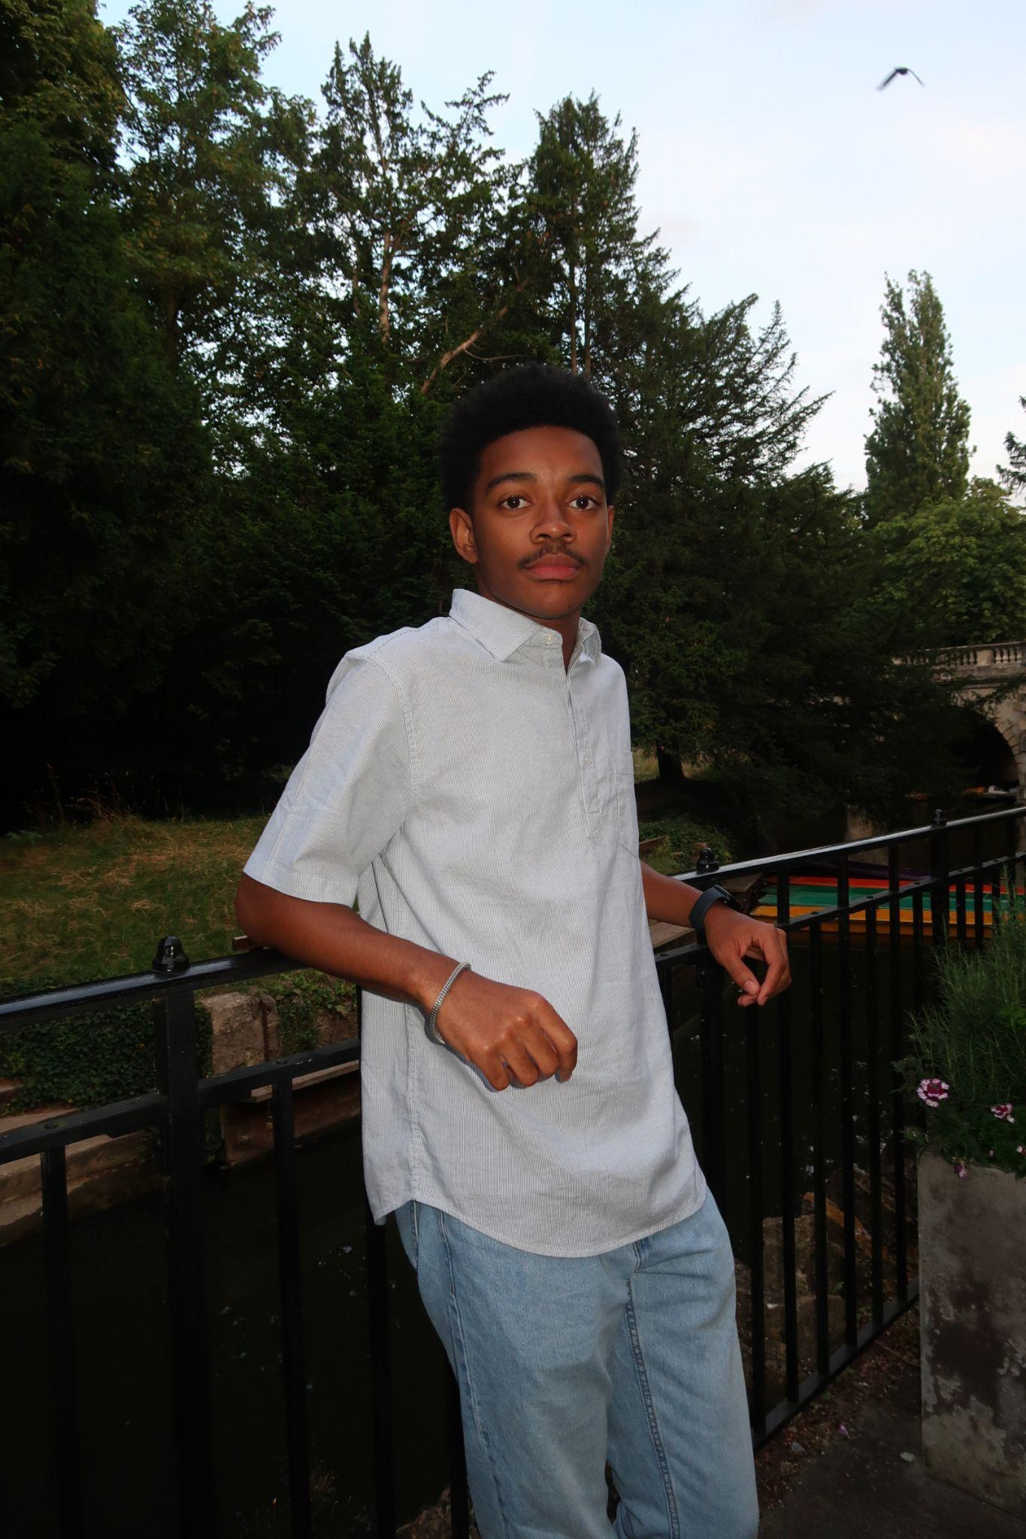

Prentiss Patrick-Carter (Director/Executive Producer, he/him) is a senior double majoring in Theater Studies and Black Studies. He’s also a FroCo, and a member of two comedy groups (Red Hot Poker & The Purple Crayon). This year, he directed Grand Concourse at Yale, and acted at Texas Shakes and Yale Repertory Theater. He’s excited to end 2025 with a great play and a great team! Looking forward to meeting you!

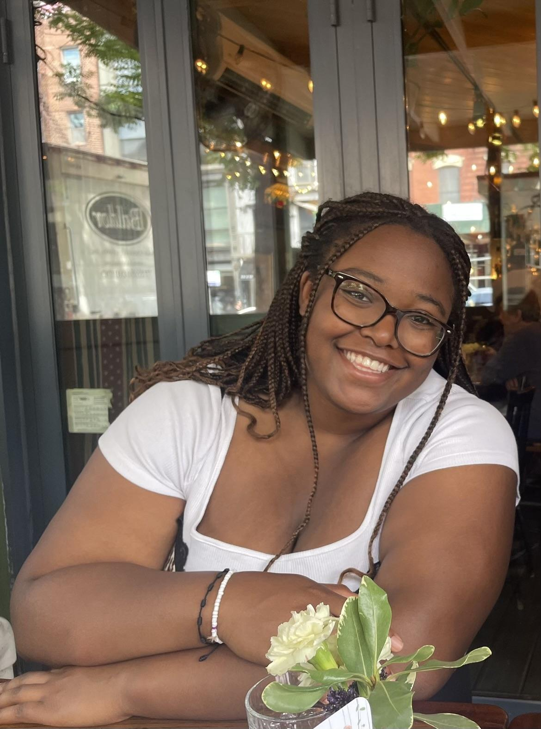
Amara Neal (Faye/Executive Producer, she/her) is a senior from Chandler, Arizona and a FroCo in Grace Hopper College. She is currently studying Theater, Dance, and Performance Studies and Economics; she’s also pursuing a Master’s of Public Health. Outside of class, she’s involved in comedy, dance, housing inequity research and more theater (duh!) She is so in love with this play, and she is so excited to work on this production with people she loves and people she will soon love: you! She’s so excited to meet you all!

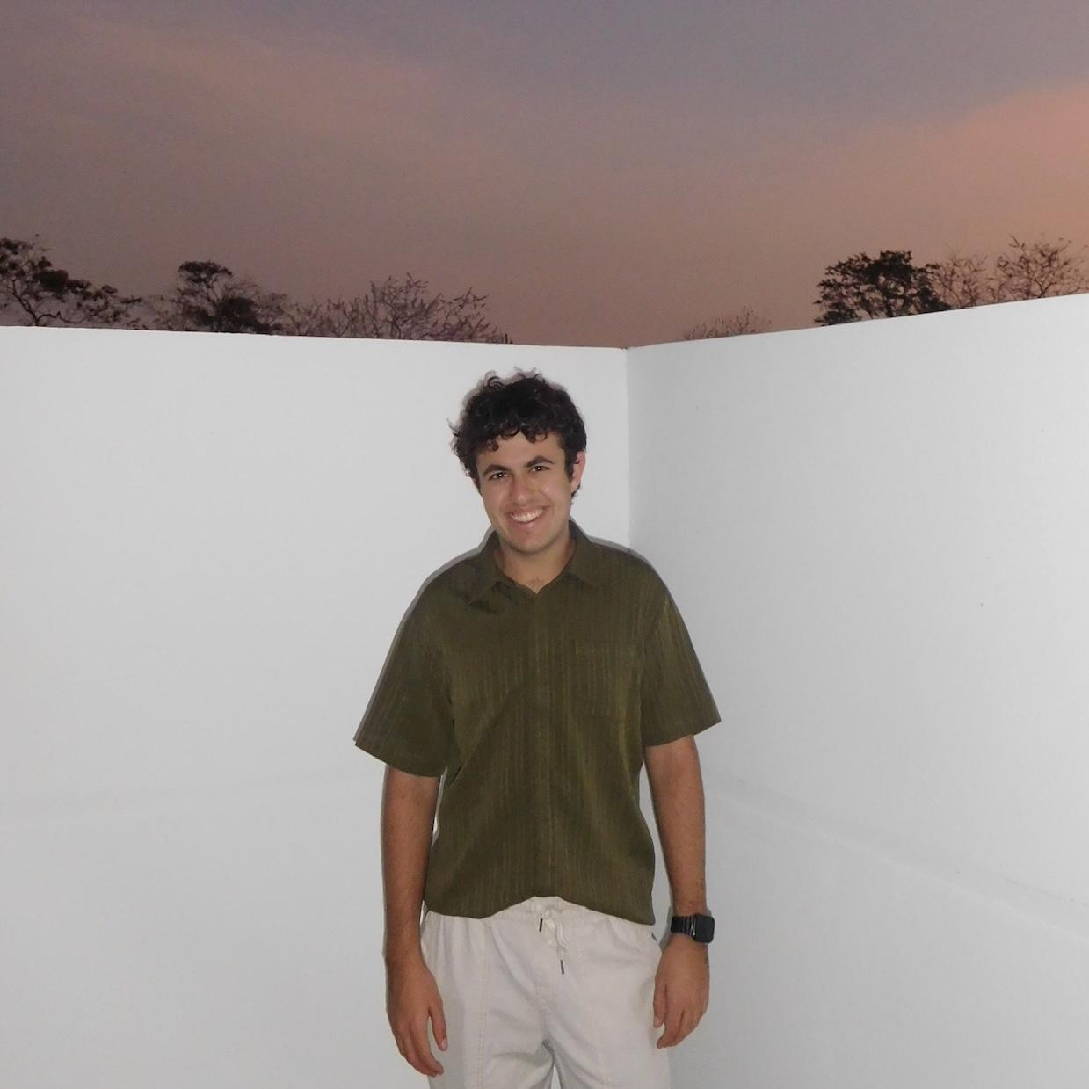
Nicolas Maynulet (Producer, he/him) is a Junior is Stiles, majoring in MCDB and TDPS. He is the director of the sketch comedy group, Red Hot Poker, and has worked on multiple productions at Yale, most recently Directing Grease and Props Designing Spelling Bee. He is excited to be producing his first play and working with such an amazing team!


Abigail Murphy (Producer, she/her) is a junior studying Theater, Dance, and Performance Studies. Most recently, she acted in Grand Concourse. Off the stage, she cartoons for various publications, and paints quite a bit. She is thrilled to be producing this show with this incredible team!

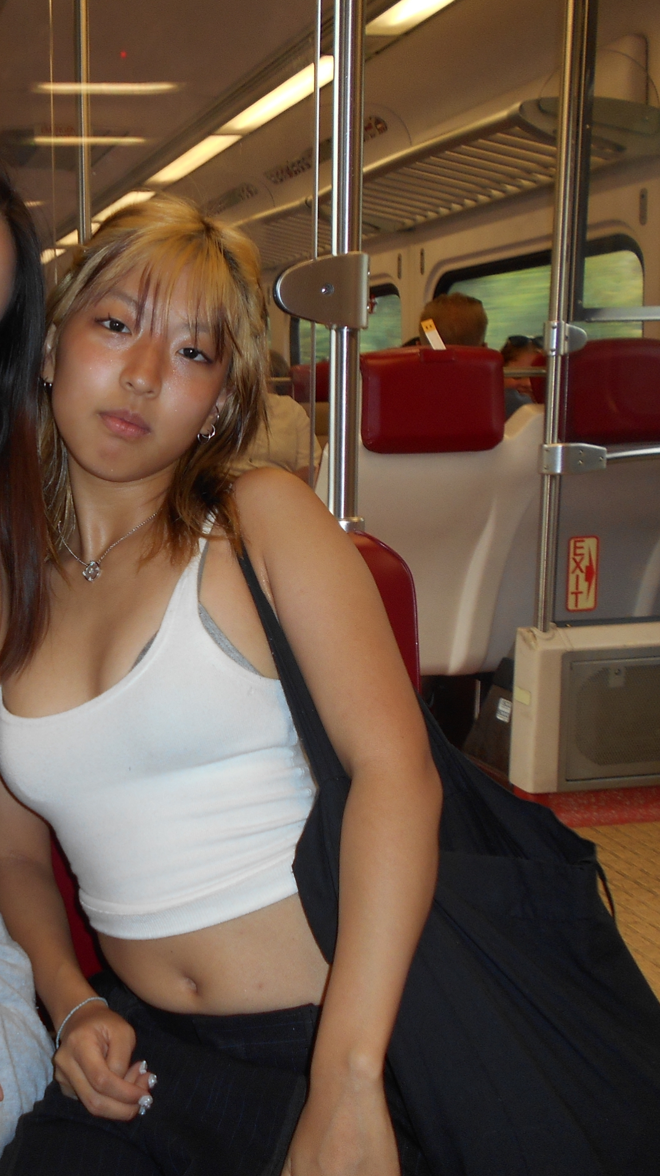
Rena Kawasaki (Stage Manager, she/her) is a rising junior in Pierson double majoring in Cognitive Science and Art hailing from Osaka, Japan. She is a member of various dance teams on campus including Rhythmic Blue and Yale Dance Lab! Her favorite Yale theater credits include Songs For A New World, 25th Annual Putnam County Spelling Bee, Fun Home, and Alice By Heart, and her favorite thing to do on campus is stage managing (as she is a gcal warrior). She loves the Skeleton Crew team and she can’t wait to meet all the beautiful people auditioning for this special show <3

The Cast
The role of “Faye” will be played by Amara Neal, but the other three roles in the show are open for casting!

Dez - (M, Black, mid-late 20s) Young, hustler, playful, street-savvy, flirtatious. Somewhere, deeply sensitive. [This role includes two kisses with Shanita.]

Shanita- (F, Black, mid-late 20s) Working class young woman. Pretty but not ruled by it. Hardworking, by the book. Believes in the work she does. Also, pregnant. Somewhere, a beautiful dreamer. [This role includes two kisses with Dez.]

Reggie- (M, Black, late 30s) White-collar man. The foreman. Studious, dedicated, compassionate. Somewhere, a fire brims.

Audition Details
What will auditions look like?
Whenever you enter the audition room, we’ll start by introducing the team, and having you introduce yourself. Next, we’ll jump into the sides. You may sit or stand, and you’ll read with Amara playing the role of Faye.
For your audition, please prepare a scene for one of the characters you’d like to be considered for. (These can be found in the Audition Sides folder.) You do not need to be fully memorized, but please be familiar with the scene, its circumstances, and be prepared to apply notes. Regardless of selected role(s), you may be asked to cold read a different scene.
Afterwards, we’ll answer any questions you may have, and thank you for your time!.

What makes a good audition?
Come prepared to play! We’re looking for characters that feel grounded, relationships that feel second nature, and dialogue full of banter. All of these characters have something – vulnerability, a dream, or a fire – below the surface. There’s no pressure to be at the finish line, but please come ready to join us in that world.

What if I have more questions about auditions?
Don’t hesitate to reach out to our team at skeletoncrewyale@gmail.com, or individual team members at our personal email addresses (listed below.)

What should I prepare for my audition?
Before your audition, make sure you’ve checked off everything in this audition checklist:
- Sign up for an audition slot on our YCA page
- Fill out the audition form, linked here!

How do I sign-up to audition?
To audition, claim a 10-minute slot on our YCA page linked here, you must have a YCA account set up to sign up for a slot.

I can’t make any of these slots. Can I send a self-tape as an initial audition?
Absolutely! Please send the self-tape to skeletoncrewyale@gmail.com. If you’re submitting a virtual audition, please start by slating (introducing yourself), and read the scene with a friend off camera. You can also submit your self-tape via the audition form.

When will callbacks be?
Callbacks will take place on September 4th! Auditionees will be notified of their callback time(s) on Tuesday, September 2nd at 12:00pm. Callbacks will consist of two more sides: one scene, and one short scene consisting of a monologue. We do not expect these to be perfect or memorized. These are mainly to gauge chemistry and hear how you interpret the text, so have fun!
If you are unable to make your assigned callback slots, please let us know as soon as possible. Callback materials and information will be communicated in the callback notification email. If you do not receive a callback, this does not mean that you will not be cast! We will be considering every auditionee for every role, regardless of which role(s) they are called back for.

When will I hear back about casting decisions?
We’ll begin notifying auditionees at 12:00pm on Sunday, September 7th. Please keep your phone on! After you’ve received an offer call, you have an hour to accept or decline the role. If you do not notify us or ask for an extension within the hour, we reserve the right to offer the role to another auditionee.

Accessibility
We are committed to accommodating any and all access needs and making sure everyone feels comfortable in the audition room! Please do not hesitate to contact us with any questions or concerns.

Contact Us
Prentiss Patrick-Carter, Director/Executive Producer, prentiss.patrick-carter@yale.edu
Amara Neal, Executive Producer, amara.neal@yale.edu
Nicolas Maynulet, Producer, nicolas.maynulet@yale.edu
Abigail Murphy, Producer, abigail.murphy@yale.edu
Rena Kawasaki, Stage Manager, rena.kawasakai@yale.edu

